**Unit-1 Setting up Magento stores**

1. **Store Setup**

**(Configure your Store)**

**1.1 General Settings**

After you have successfully installed Magento 2, you will need to configure the general settings for your store.The first thing you will need to do, is accessing the admin dashboard of your Store and navigating to the Stores>Configuration section.

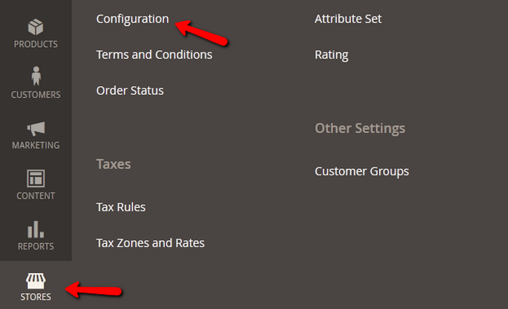

Here, select the General option from the navigation menu on the left and you will be presented with these settings to configure.

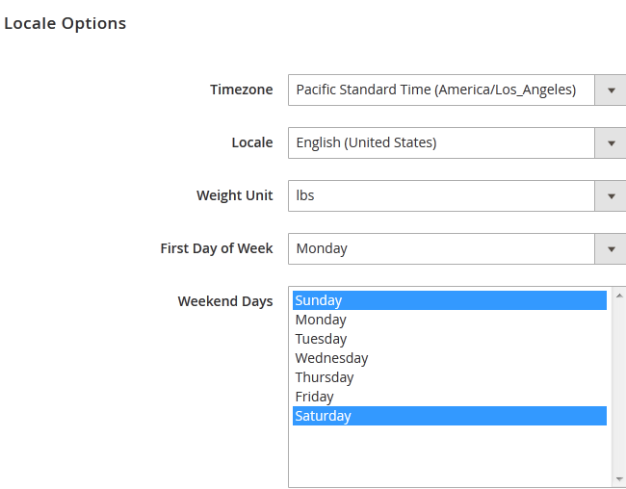

 Locale Options:

* Timezone – The Time zone of the Store
* Locale – The default language
* Weight Unit – The weight unit that will be used for the products of your store (and in weight shipping)
* First Day of Week – Setup the Calendar of your store
* Weekend Days – Select the Weekend Days for your store

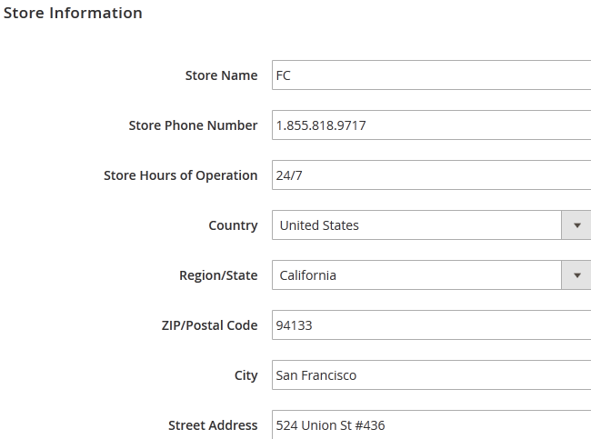

 Store Information:

* Store Name – The name of your Store
* Store Phone Number – The phone number for contact
* Store Hours of Operation – The hours during which your store is open
* Country – The Country in which the store is situated
* Region/State – The region in which the store is located
* ZIP/Postal Code – The ZIP/Postal Code of the area in which the store is located
* City – The City in which the store is located
* Street Address – The Street Address of the Store
* VAT Number – The VAT Number for your store (this will make sure VATs are calculated correctly)

**1.2 Contact Us page**

Magento 2 comes pre-defined with a Contact Us page which can be used by your customers to leave feedback or ask questions. The link for the page is located in the footer but can be moved to another place if needed.

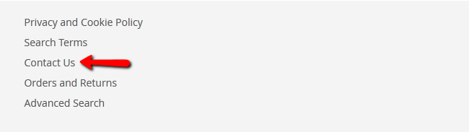

 To modify the content of the contact form, login to your admin dashboard and navigate to the Stores>Configuration>Contacts section.



You will see the following options: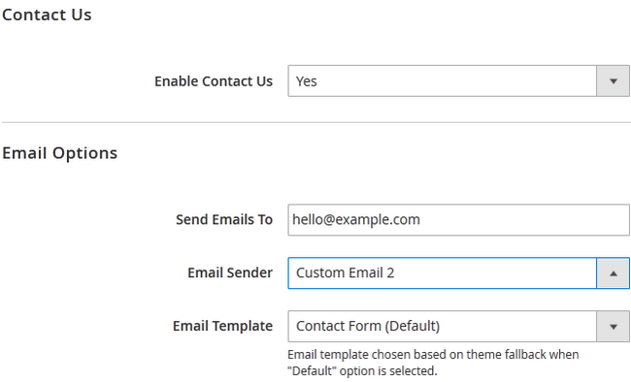

* Enable Contact Us – This should be set to Yes if you wish to have the Contact Us page on your Store
* Send Emails To – Here type the email address on which you want to receive all of the  messages submitted via the form
* Email Sender – This option is used for the email "From" field.
* Email Template – From here you can select the template of the email. You can create new Email Templates by going to Marketing>Email Templates.

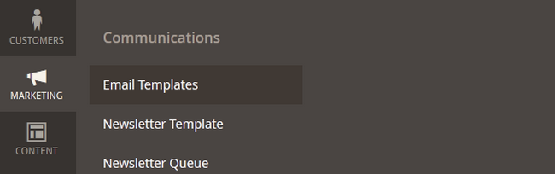

 Click on the Save Config button to apply the changes.

**1.3 Enabling SEF URL’**s (Search Engine Friendly)

Search Engines will craw your website in order to index all of your Store’s content and products. To make this process more efficient you can optimize your Magento 2 website by enabling Search Engine Friendly URLs (SEF URLs). This will also make your URLs easier to read by your customers and on websites when they are being shared. Usually this feature is enabled by default, but if you are not seeing the URLs as they should be you will have to re-enable it. To activate the SEF URLs for your Store, you will need to first login to your admin dashboard and then navigate to the Stores>Configuration>Web section.



Now simply select Yes from the drop-down menu on the Use Web Server Rewrites option.

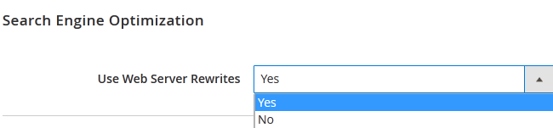

 Magento uses the Apache mod_rewrite to create the SEF URLs. If your Magento store is installed in the root of your domain (http://domain.com) you will not have to perform any changes in this file. However, if your Magento store is located under a subdirectory (http://domainc.om/magento/) you will need to edit the .htaccess file by changing the following line:

#RewriteBase /magento/

to

 RewriteBase /your-magento2-folder-here/

1. **4 Enabling SSL**

The SSL protection of online stores has become standard procedure in the e-commerce field. Not only that it will add security for your visitors during they sign up, but also protect their credit card and personal information by encrypting it. Having an SSL activated for your Store will also attract more clients as your business gains credibility.

 FastComet Magento 2 Hosting E-Commerce package is specially optimized to provide fast and secure hosting environment for all Magento features and comes with Free GlobalSign SSL Certificate.



 After you have the SSL installed on your domain, you will need to enable it via the Magento 2 admin dashboard by navigating to the Stores>Configuration>Web section.

Now select the Base URL (Secure) and edit the first field Secure Base URL by changing http:// to https://

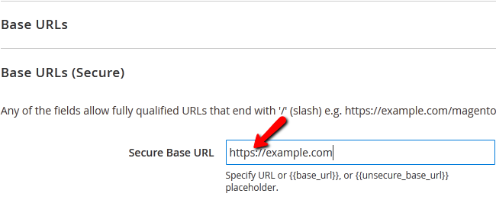

 If you wish to make the entire Store’s front-end to open only via HTTPS, set Use Secure URLs on Storefront to Yes. Note that this might have negative impact on your website’s performance as it will load every element via https instead only the sensitive information.

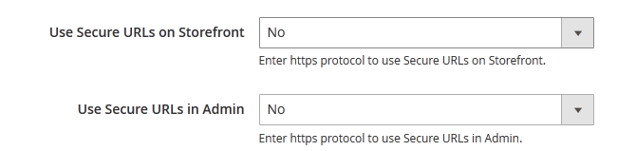

To secure the Admin area of your Store with SSL, set the Use Secure URLs in Admin option to Yes.

**1. 5. Currency Setup**

Changing the currencies for your Magento 2.0 Store is easy as you will not need to add a new currency and configure its value, symbol and shortcode. You will simply need to login to your admin dashboard and navigate to the Stores>Configure section from the main admin panel.



Now access the General>Currency Setup section.

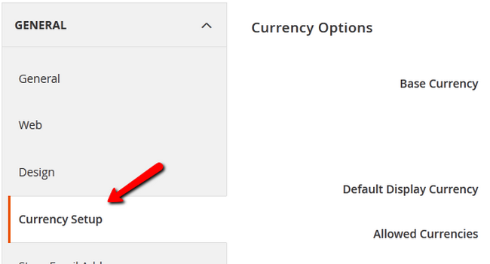

 Here, you will be able to change the Base and Default currencies for your Store from a list of pre-defined currencies.

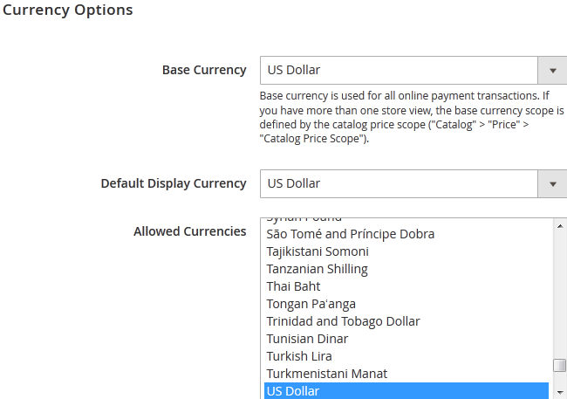

**1.6. Design Settings**

With Magento’s version 2.1 changes some of the design options have switched menus inside the Admin Dashboard, so due to a request from our users, how to find the design settings and use them to change your website’s favicon, logo and footer copyright message among other things.

The first thing you will need to do is to log in your admin area inside your Magento website. Afterwards, navigate to CONTENT -> Configuration.

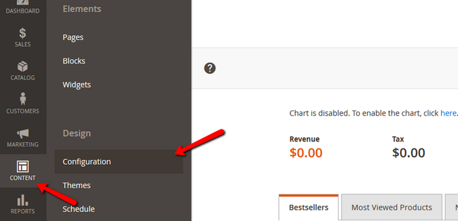

Now select the store and level on which you wish to edit the design by clicking on the Edit action.

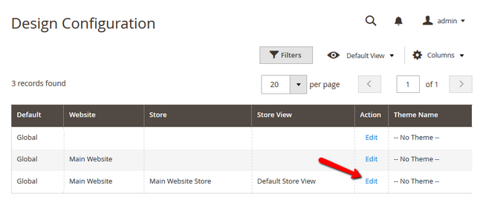

#### Theme Warning

Note that some of these settings may not apply unless you choose the applied theme (if a custom one is applied at the moment).

Select the Other Settings submenu and expand the HTML Head option.

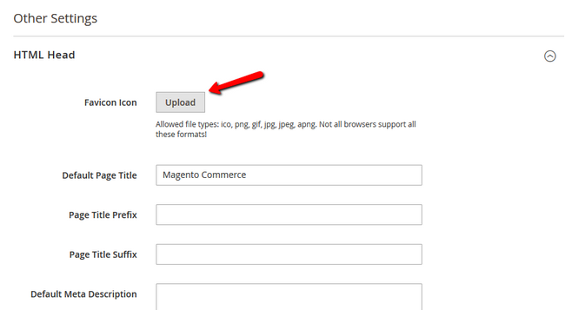

 Here you will be able to add your favicon. Due note that Magento supports the following file types for favicon: .ico, .png, .apng,.gif, .jpg, .jpeg, .svg. and while not all browsers support all these formats the most used and well known format for a favicon is the.ico.

The other important option here is the Default Title. This title will be used for any page that does not have a specific Title predefined for it. The prefix and suffix options can be to add a certain word phrase before or after all page titles in bulk.

 To add a new Logo for your Store, expand the Header option which is right below the HTML Head one. The allowed formats are .png,.gif, .jpg and.jpeg.

**Unit -2: Product and Category Management**

**2.1 Products and Categories**

Product categories to better sort the content of your Store and improve the user experience, as searching for specific products by the customers will become much easier.

Magento 2 comes with a default root category but you can create your own and name it as you like. To do that, you will first need to login to the admin dashboard of your Magento 2 and navigate to Products>Categories.

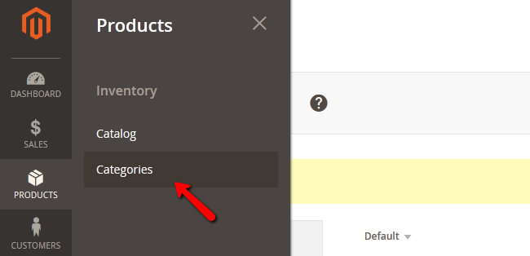

 We have already created a root category for Men’s Clothes so let us create one for Women as well:

* Name – The Name of the category
* Is Active – Activate/Deactivate the category
* URL Key – The URL leading to this directory
* Description – A short description of the category and what it contains

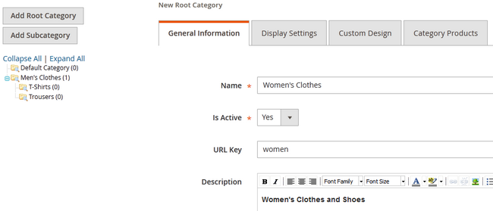

* Image – Here you can choose and image for the category
* Page Title – The title of the page that will show on your browser’s tab
* Meta Keywords – Used by search engines to index the category’s page
* Meta Description – This description will help search engines to better understand the content of the category
* Include in Navigation Menu – If you have more than 1 root categories you will need to set this to Yes.

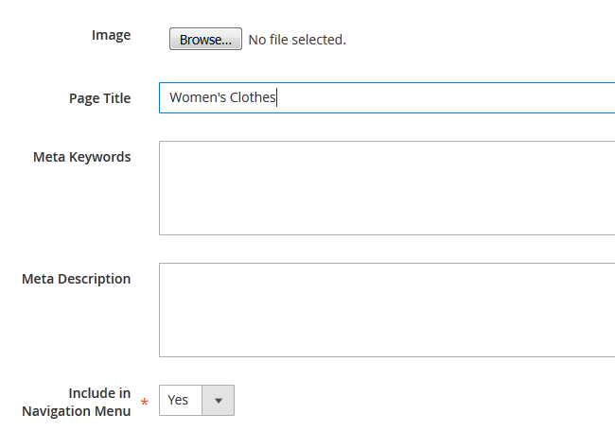

 When you are ready, click on the Save Category button to apply the changes and create the category. To create a subcategory for the new root category, simply select the root category and click on the Add Subcategory button.

**2.2 Attributes**

Setup your products’ attributes. Attributes are an important part of your product catalog as each of them can help potential customers with choosing a certain product that corresponds to their needs. Users will also be able to search and compare products based on their attributes.

 Your Magento 2 store includes predefined attributes such as Name, Price, and Description, that can be used for any product. In addition to these, you can create new custom attributes to help your clients with their choice.

 To create a new attribute login to your website’s admin dashboard and navigate to the Stores>Attributes>Product section of Store

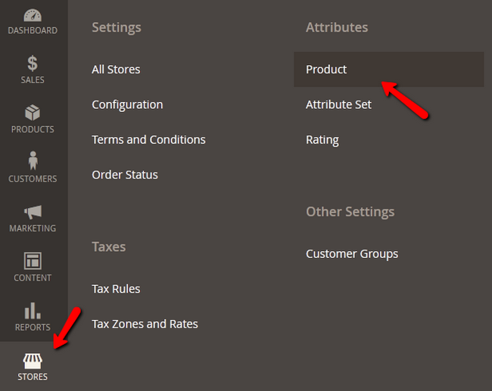

 This will open the list of all attributes currently available on store. To create a new one click on the big orange Add New Attribute button.

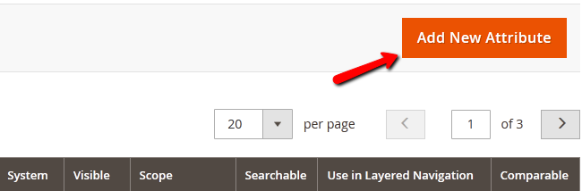

 Now you will be able to configure the attribute.

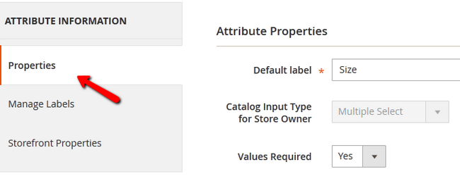

 We will configure a “Size” attribute which will require multiple selections from the different sizes.

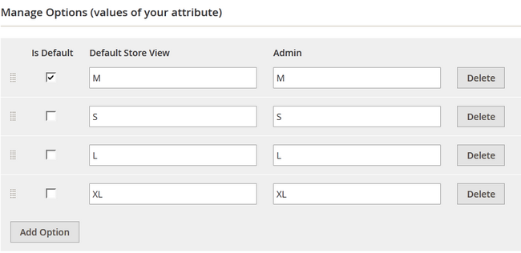

 In the Advanced Attribute Properties you can setup:

* Attribute Code – The name of the attribute that will be used by the system
* Scope – allows you to declare the attribute value saving scope like
* Website - the value of this attribute for a product can be different in different Websites but have to stay the same between Store Views contained under the same Website.
* Store View - the value of this attribute for a product can be different in all Websites and all Store Views
* Website - the value of this attribute for a product can be different in different Websites but have to stay the same between Store Views contained under the same Website
* Global - the value of this attribute for a product must be the same for all websites and stores

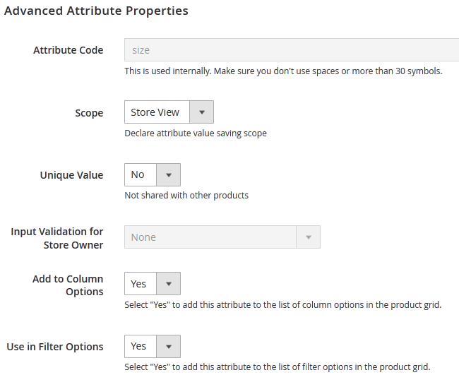

* Unique Value – Set this to Yes, if you want the data saved in this attribute to be unique for each product. If you have different products made of the same material or having the same feature, leave this to No
* Input Validation for Store Owner – If you want to validate the data before applying changes to the attribute, select Yes
* Add to Column Options – To add this attribute to the list of column options please select Yes
* Use in Filter Options – If you set this to Yes the attribute will be added to the list of filter options

From the menu on the left, click on the Storefront Properties tab to configure the frontend behavior of the attribute.

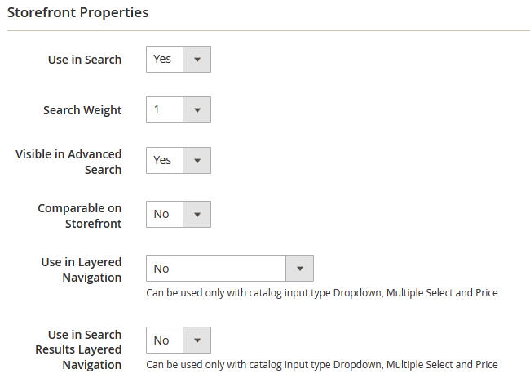

To save your new attribute click on the Save Attribute button on the top right corner of your screen. This will bring you back to the attributes list page on which you should see your new attribute.

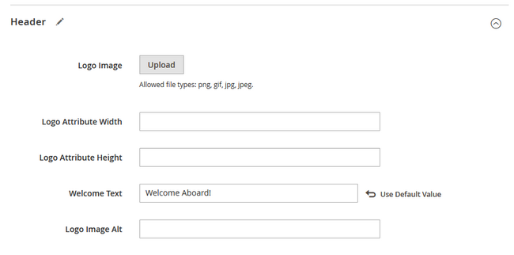

Now you can add/change the logo, configure its width and height as well as add a Welcome Message for your store and alternative text for the logo so search engines can crawl it correctly.

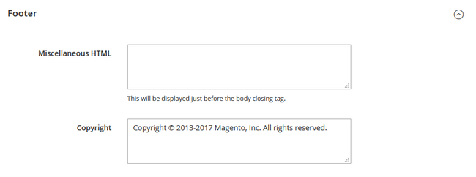

With this you can substitute the default Magento copyright message or any custom one that may appear with a theme you have enabled with your company’s.

Don’t forget to click the Save Configuration option in the upper right corner to save the changes you just made and Flush your Magento Cache if caching is enabled.

**2.3 Add Products**

As with all stores, you will need to populate yours with products and configure each one of them. The process is seamless and easy to be completed by anyone.

To add a new product, please access your admin area and navigate to the Products>Catalog from the main admin panel. If you still haven’t created a Category.

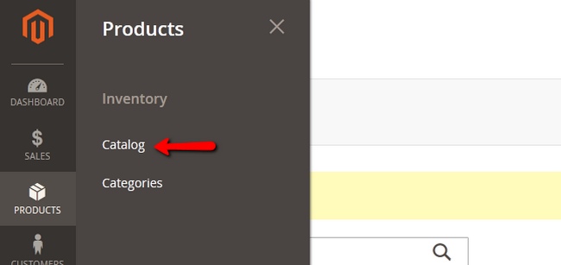

 Click on the big orange Add Product button to start configuring a new Product.

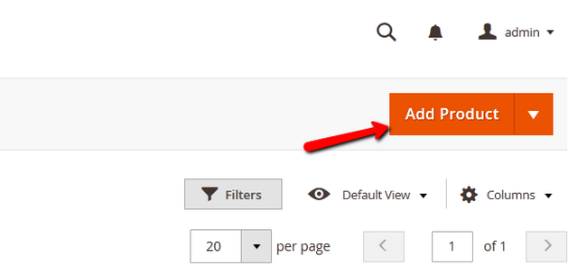

 Now you will be able to configure:

* Name – The name of the product
* SKU – The Stock keeping Unit of the product (for tracking the inventory of your store)
* Price – The price value of the product
* Tax Class – The Tax Class for the product
* Images and Videos – Select an image/video representing the product

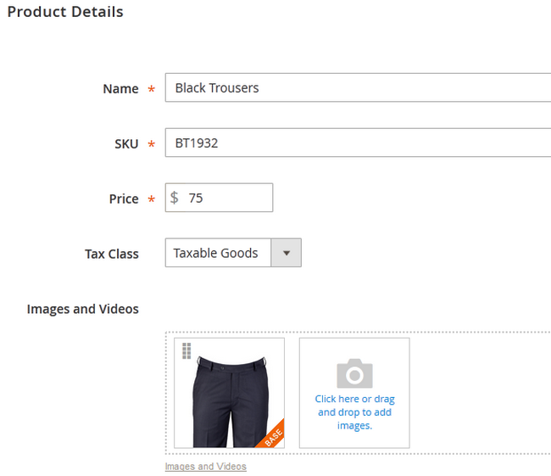

* Quantity – The amount of quantity currently in stock
* Weight – The weight of the product (for shipping purposes)
* Categories – The exact category you wish to place this product in
* Description – A short description regarding the features of the product

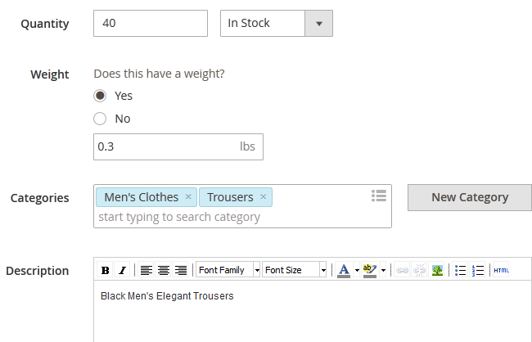

You should thing about the Search Engine Optimization (SEO) of your new product. If you click on the corresponding tab from the menu bar on the left you will be presented with:

* URL Key – This will be the end of the URL when your product is being accessed (<http://example.com/magento/URLkey>). If not filled, it will be automatically created from the product name
* Meta Title – Specifies the title of the web page appearing on the browser
* Meta Keywords – These keywords will help the search engines with indexing your product page
* Meta Description – Describes the content of the product page to the search engines

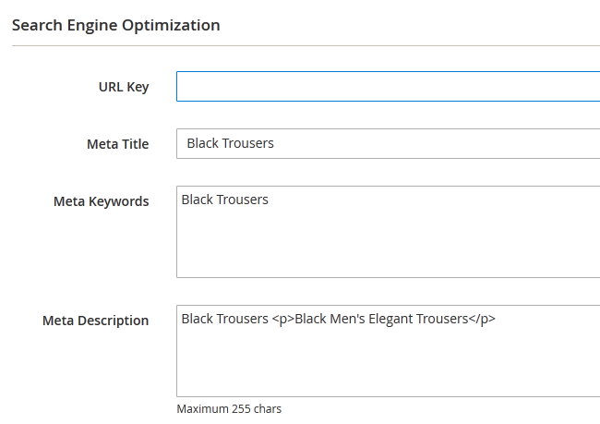

 Before you add the product, you can add a new attribute by clicking on the Add Attribute button.

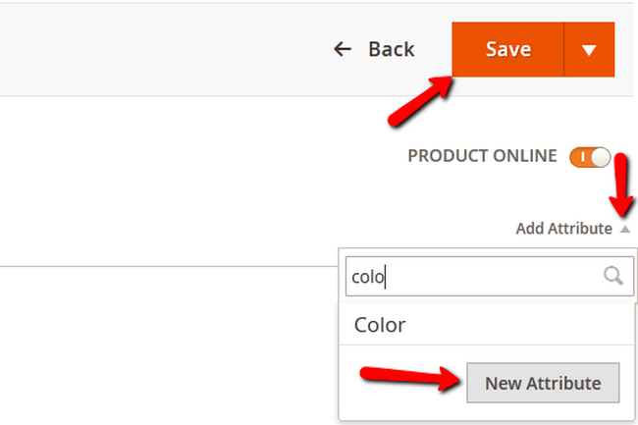

 When you are done, click on the Save button to finalize the product creation process.

#### 2.4 Reviews and Ratings:

#### To manage your product's reviews and ratings:

* Step 1: Add a new Rating Criteria
* Step 2: Add a new Review

### **Step 1** **Add a new Rating Criteria**

Let us add a new Rating Criteria for our store called Delivery. With it the customers will be able to rate the delivery service that we offer when submitting a review.

Login to your store’s admin dashboard and navigate to Stores>Rating from the main admin panel.

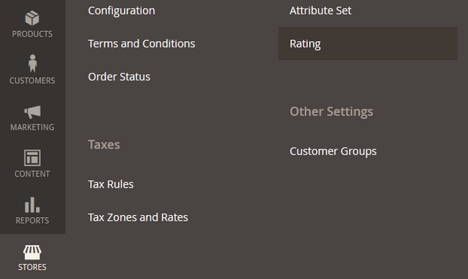

 Click on the Add New Rating button.

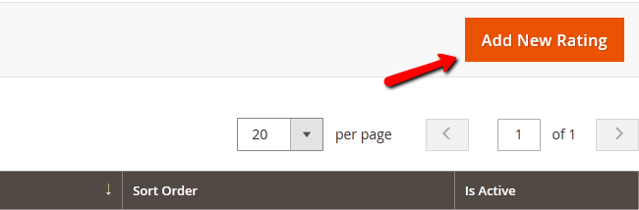

 We will name the Default Value – Delivery and set the visibility to Default Store View. We will also checkmark the new rating as Active and set the Sort Order to 3 as we have some existing Rating Values

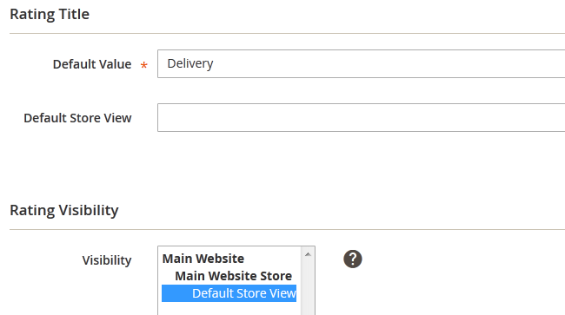

**Attention**

 If the predefined criteria seem active but are not showing in the review submission process, you will need to set their visibility to Default Store View and click Save Rating to save and apply the setting).

 When you are ready, click on the Save Rating button to add the new Value.

**Step 2** **Add a new Review**

To add a new Product Review, you will need to navigate to the Marketing>Reviews section of your admin panel.

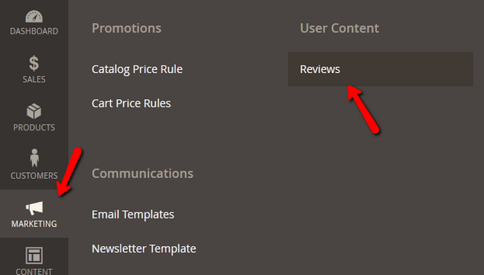

 Here you can manually add a new Review (if you have received such via some other communication method like email or on your store’s Facebook page) or select from the user submitted reviews and make them visible on your website. To do the second, select a review and click its edit button.

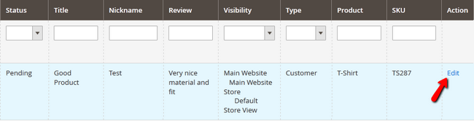

 Here you will see the review details that include the Product which is being reviewd, the author of the review with its account and email, the Ratings and Status which you can change to approved in order to add the review.

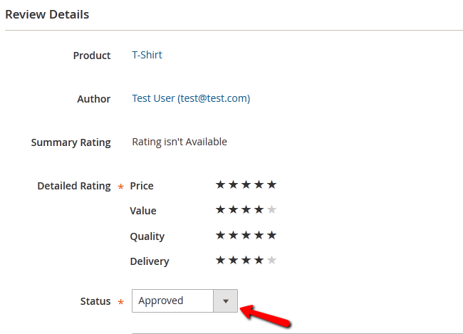

 Below the status drop-down menu you will also see the Nickname of the author, the summary of review and the review itself.

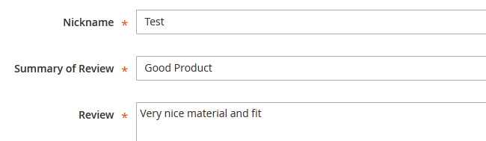

 You can edit all of those fields and you should do so to remove any grammatical or spelling mistakes so the review looks better on your website’s front-end.

 Click the Save Review button to add the review. This will make it visible on the front-end in the Reviews tab below the product.

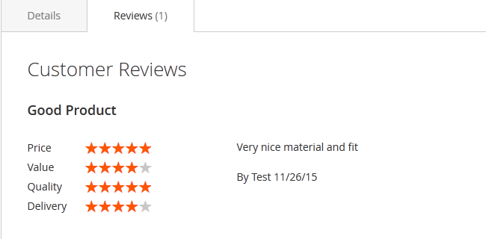

**2.5 Display product in front page**

Most users find it difficult to display the products they have added on the home page of their store. How to add a widget for your products and feature them on your home page?

 You will have to first login as an administrator to your Magento 2 based store’s back end and navigate to Content>Pages.

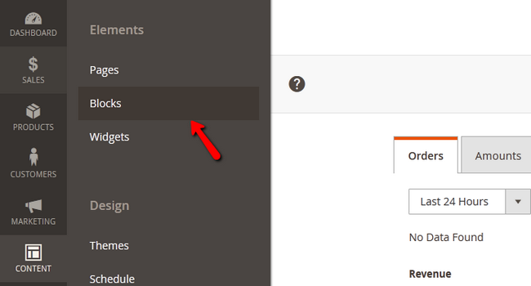

 Here you will see a list of your store’s pages and by clicking on the Select option you will be able to Edit your home page.

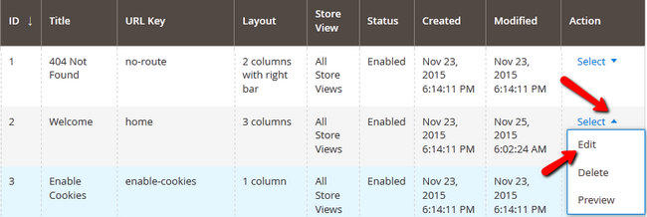

In the Page Information tab, you can select a Title, URL, store view and Status of the page.

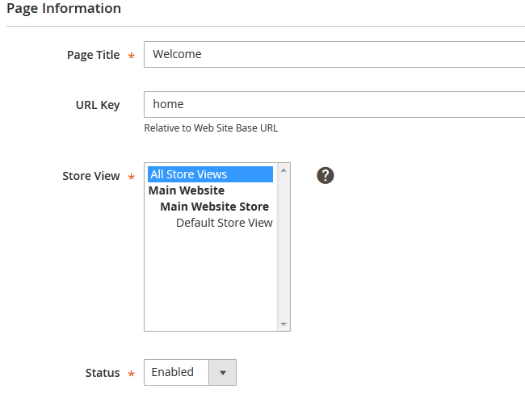

 Click on the Content tab and click on the insert widget button to add a widget for this page.

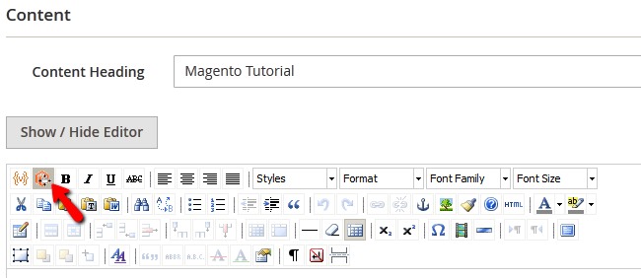

Now you will be able to choose one of the widget types available. We chose Catalog New product List to feature the newest products from the catalog on the main page. You will also be able to select the number of products on the screen as well as the exact way they are being displayed.

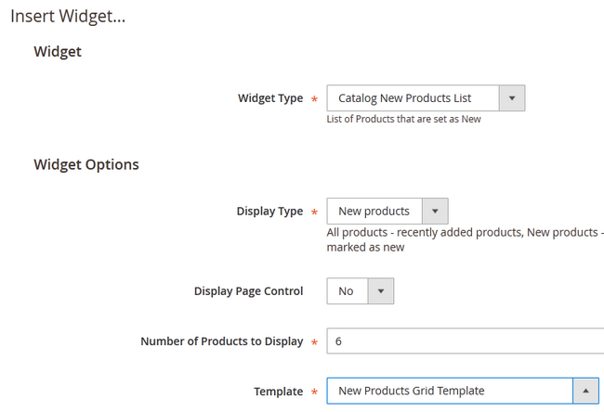

 When you are ready get back to the Content tab by clicking on the Insert Widget button and then click the Save Page button to apply the changes to the page.

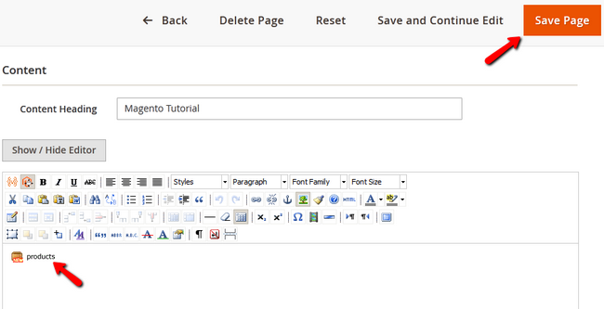

**2.6 CMS (Content Management System)**

The Content Management System (CMS) of your Magento 2 Store is used for creating new pages, blocks and widgets. You can combine those 3 elements to create custom static pages that display parts of your catalog or other useful to the customer information.

 To effectively use the Magento 2 CMS, you will need to:

* Step 1: Add a new Page
* Step 2: Add a new Block
* Step 3: Add a new Widget

### **Step 1** **Add a new Page**

To create a new Page for your Magento 2 Store, you will need to login to your admin area and navigate to the Content>Pages section.

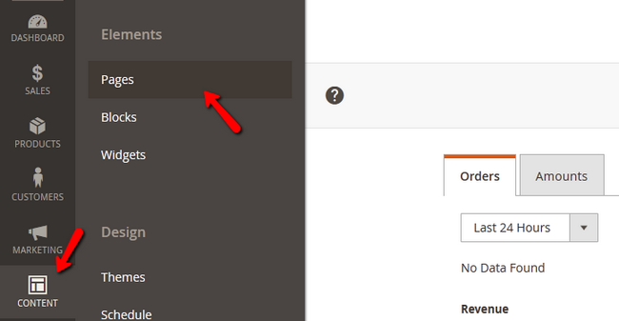

 Here you will see all of your Store’s pages. Click on the Add New Page button.

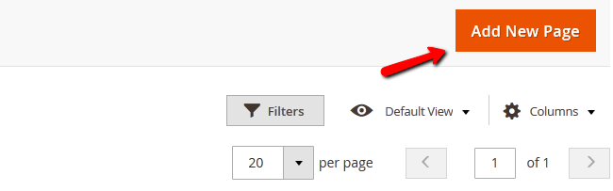

 Now you can Name the page and set a custom URL for it. You can also choose on which store it can be viewed and set its status to enabled or disabled (hidden).

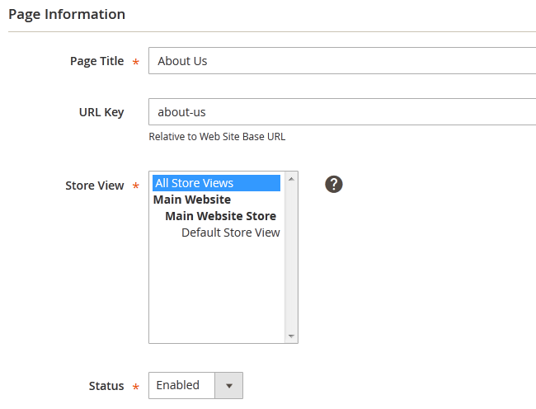

In the content tab you can add the heading for the page and the content plus any widget you wish to be displayed on this page.

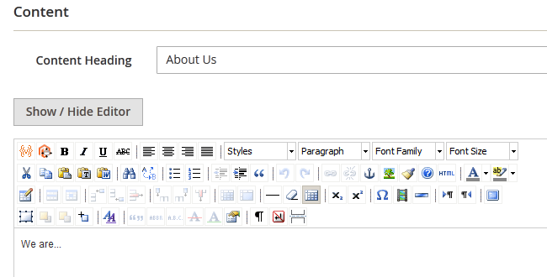

 When you are ready with the configuration of the page, click on the Save Page button to create it.

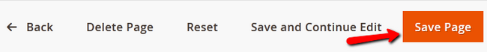

 Now you can add this new page on any other by using a link widget. For example if you want to add this page as a link on the home page, you will need to get into your Home Page’s edit menu, select the content tab and click on the insert widget button.

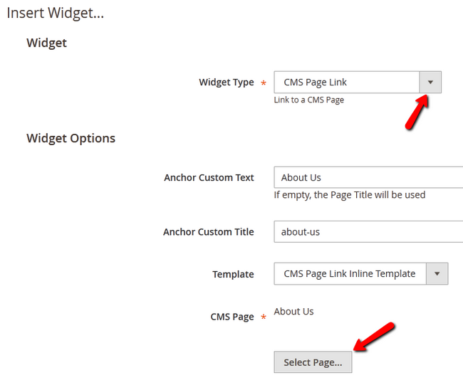

 After you have configured and inserted the widget, don’t forget to also save the page and refresh the page cache if necessary.

**Step 2** **Add a new Block**

Blocs can be used to separate different categories of your products when featuring them on your home page. To create a new block you will need to navigate to Content>Blocks.

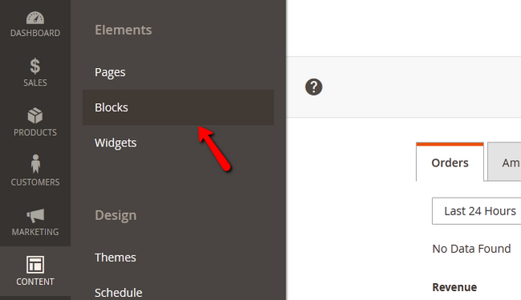

 Let us add a new block by clicking on the Add New Block button and again you will have to configure the new element.

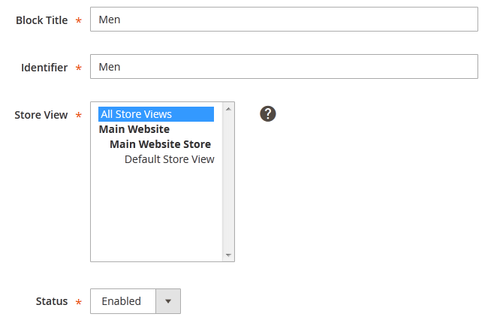

From the options you have, the most important is the identifier as it can be used later for implementing this block into a page via the code of the page. When you are done, click on the Save Block button to create the block.

**Step 3** **Add a new Widget**

To access the widget management page you will need to navigate to Content>Widgets from your admin dashboard.

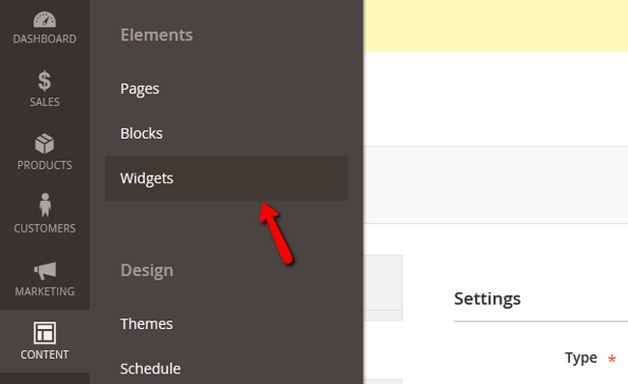

Now you will need to click on the Add Widget button.

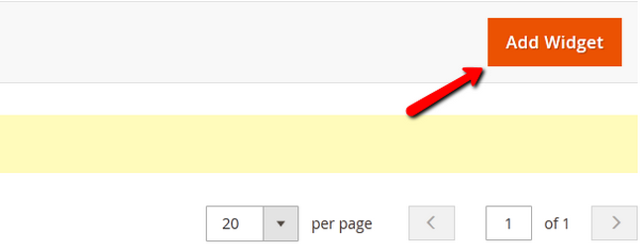

 Now you will need to select the type of widget and theme for it. Click on the Continue button to proceed to the storefront settings.

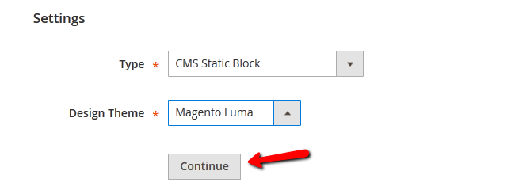

 Now you can set a Title and Store View for the widget while the Type and Theme are now locked and grayed out from editing.

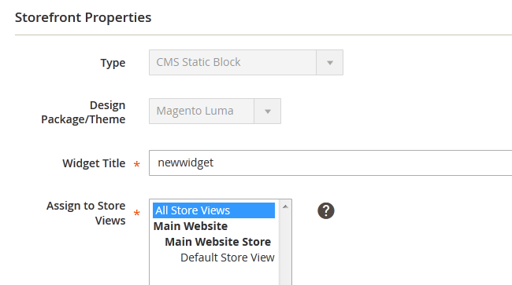

You can also select a layout for the widget as shown on the storefront.

